

PROJECT REPORT
COURSE CODE :24ADI204
COURSE TITLE: DATA SCIENCE AND VISUALIZATION

HOSPITAL READMISSION CRISIS
SUBMITTED BY:
ANUSRI T-24BAD010
GURUPRASAD N-24BAD029
SHALINI S-24BAD409

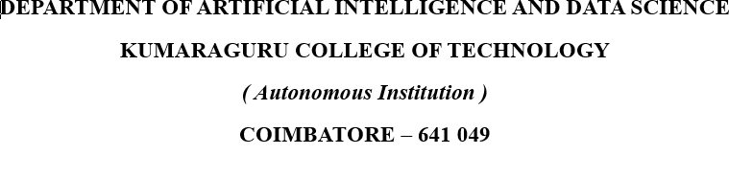

INTRODUCTION:
Hospital readmissions, especially within 30 days of discharge, are a major challenge in modern healthcare systems. Frequent readmissions increase medical costs, burden hospitals, and indicate possible gaps in treatment, discharge planning, or follow-up care.
Patients with chronic illnesses such as diabetes are at higher risk of being readmitted due to complications, poor medication adherence, or lack of post-discharge support.
This project analyzes diabetic patient hospital records using data science techniques such as data preprocessing, exploratory data analysis (EDA), and outlier detection to understand the key reasons behind patient readmissions. Special focus is given to handling outliers in the “time in hospital” feature, as unusual lengths of stay can affect the accuracy of analysis and predictions.

DOMAIN:
Healthcare, Hospital Management, and Medical Data Analytics
This project belongs to the healthcare analytics domain, where hospitals and healthcare providers use patient data to improve treatment quality and reduce unnecessary readmissions.
Data science helps analyze patient-related factors such as:
- Age
- Number of lab procedures
- Number of medications
- Diagnoses
- Time spent in hospital
- Previous admissions
By identifying readmission patterns, hospitals can improve patient care, reduce costs, and enhance healthcare services.

PROBLEM STATEMENT:
Hospital Readmission Crisis – Diabetic Patient Readmission Analysis
Hospital readmission within 30 days is a critical issue in healthcare, especially for diabetic patients who often require continuous monitoring and treatment. Readmissions may happen due to complications, ineffective treatment, poor discharge planning, or inadequate follow-up care.
The challenge is to analyze diabetic patient data to identify the major factors contributing to hospital readmissions. Since the dataset contains variations and outliers in the “time in hospital” feature, proper preprocessing and outlier handling are necessary to ensure accurate analysis.

PROBLEM ABSTRACT:
Hospital readmission has become a major concern for healthcare institutions because it affects patient health outcomes and increases treatment costs. Diabetic patients are particularly vulnerable because of the complexity of managing blood sugar levels, medications, and related complications.
This project uses the Diabetic Patient Readmission Dataset to study hospital readmission trends and identify factors associated with patients returning within 30 days. The analysis includes:
- Data cleaning and preprocessing
- Handling missing values
- Detecting and treating outliers in “time in hospital”
- Performing EDA to identify important trends
The findings can help healthcare providers improve discharge strategies, enhance patient monitoring, and reduce avoidable readmissions.

OBJECTIVE:
- To analyze diabetic patient hospital records and understand the dataset structure.
- To preprocess the data by handling missing values and removing inconsistencies.
- To detect and handle outliers in the “time in hospital” feature.
- To perform exploratory data analysis (EDA) to identify patterns affecting readmission.
- To determine key factors responsible for readmission within 30 days.
- To support better healthcare decisions for reducing readmission rates.

CHALLENGES:
- Complex Patient Conditions: Diabetic patients often have multiple health issues, making analysis more difficult.
- Missing or Incomplete Data: Healthcare datasets may contain missing test results or patient details.
- High Readmission Risk Factors: Many medical and social factors influence readmission.
- Data Privacy and Sensitivity: Patient records must be handled securely and ethically.
- Healthcare Cost Pressure: Reducing readmissions is important for both hospitals and patients.

WEEK 1:
TEAM FORMATION AND DATA HUNTING

TEAM.NO:17
TEAM MEMBERS:
24BAD010-ANUSRI T
24BAD029-GURUPRASAD N
24BAD409-SHALINI S
GITHUB LINK:
https://github.com/guru16-02/TEAM-17-24ADI204.git
ONEDRIVE LINK:
https://kumaragurudtsteam-my.sharepoint.com/:f:/g/personal/anusri_24ad_kct_ac_in/IgDNfJyctDzZTox4MlIck6uqAR5CLjtEoHjoRbHU9x1dry4?e=cJE3R4

DATASET:
Diabetes readmission
https://www.kaggle.com/datasets/brandao/diabetes?select=diabetic_data.csv

ABOUT DATASET:
The dataset contains approximately 101,766 diabetic patient hospital records collected from 130 hospitals in the United States between 1999 and 2008. It includes various attributes describing each patient encounter, such as patient demographics, admission details, discharge information, number of lab procedures, medications, diagnoses, and length of hospital stay.
The dataset also includes a target variable called readmitted, which indicates whether a patient was readmitted to the hospital within 30 days (<30), after 30 days (>30), or not readmitted (NO).
TEAM CONTRIBUTION:
TEAM MEMBER | CONTRIBUTION
ANUSRI T | Created and organized a shared OneDrive repository to store and manage project documents and resources.
GURUPRASAD N | Set up and maintained the GitHub repository to enable version control and collaborative development.
SHALINI S | Analyzed and interpreted the project problem statement to identify key challenges and objectives.

WEEK 2:
KNOW YOUR DATA
OBJECTIVE:
The objective is to gain an initial understanding of the dataset before performing further analysis. This involved loading the dataset into the Python environment, examining its structure, identifying data types, and generating a preliminary overview of the data.
PACKAGEs: numpy,pandas
METHODS: head(), tail(), info(), describe(), isnull(), sum()
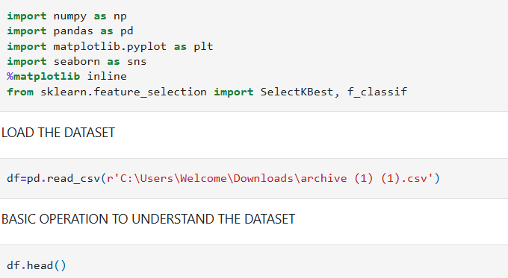
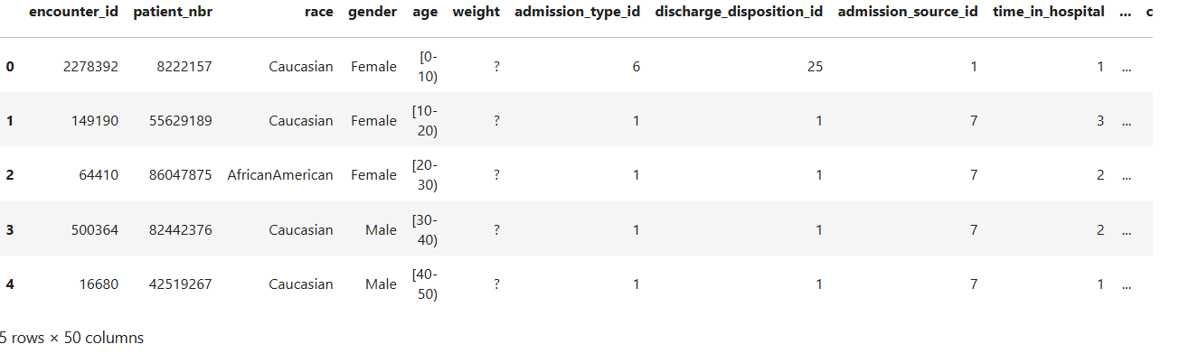
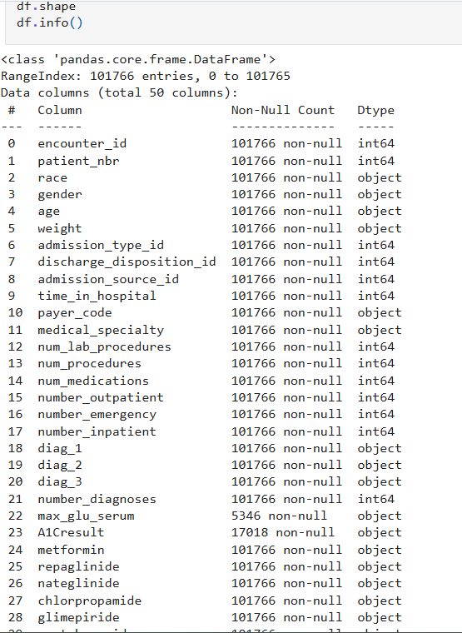
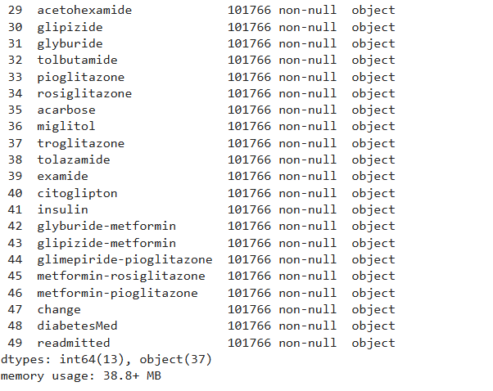
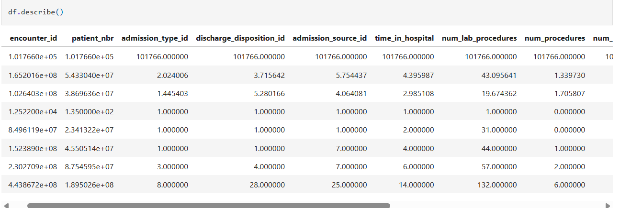
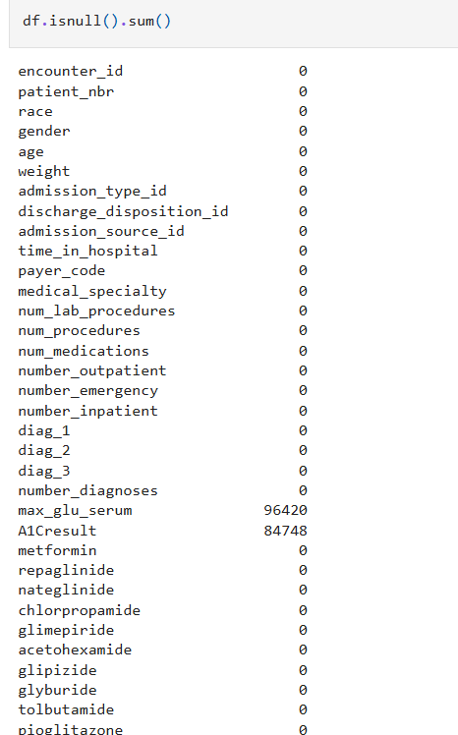
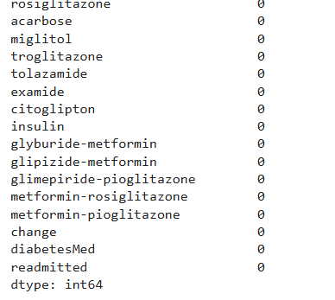
INTERPRETATION:
The dataset contains 101,766 diabetic patient hospital records with 50 features, making it suitable for hospital readmission analysis. It includes patient details, hospital stay information, lab procedures, medications, diagnoses, and the target variable readmitted.
Most columns have no missing values, showing good data quality. However, max_glu_serum (96,420 missing) and A1Cresult (84,748 missing) have many missing values, indicating that these tests were not conducted or recorded for many patients.
The time_in_hospital feature is important for identifying patient stay duration and outliers. Overall, the dataset is useful for analyzing factors that influence diabetic patient readmission and improving healthcare decisions.

TEAM CONTRIBUTION:
TEAM MEMBER | CONTRIBUTION
GURUPRASAD N | Implemented the Python code to load the dataset and perform the initial data inspection.
SHALINI S | Prepared the documentation and recorded the weekly progress for the project report.
ANUSRI T | Analyzed the dataset attributes and interpreted the statistical summary generated from the data.

WEEK 3:
THE CLEANING SPRINT
OBJECTIVE:
To improve the data quality of the dataset by identifying and handling missing values and detecting outliers. Data cleaning is an important preprocessing step that ensures the dataset is reliable and suitable for further analysis and model building. This stage focuses on applying imputation techniques to handle missing values and statistical methods to detect outliers in the transaction amount feature.
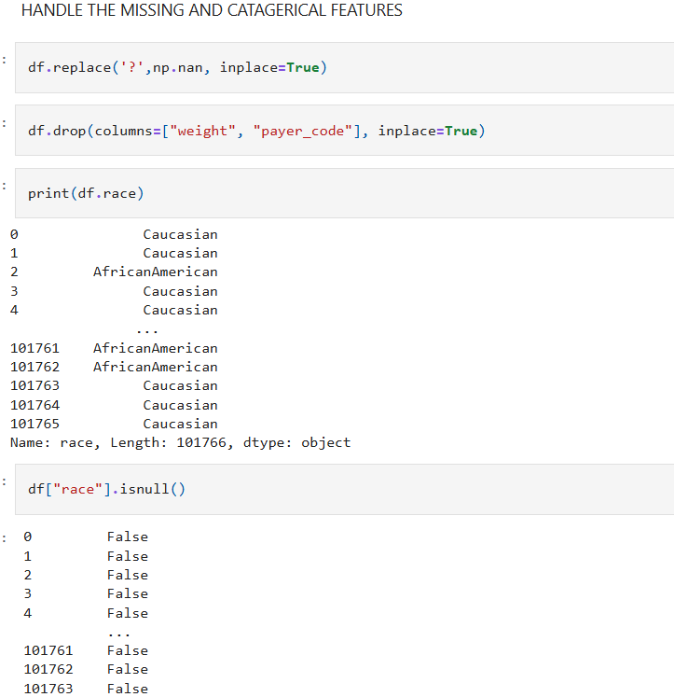
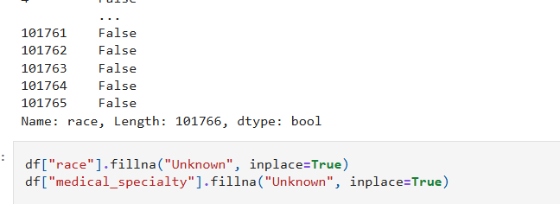
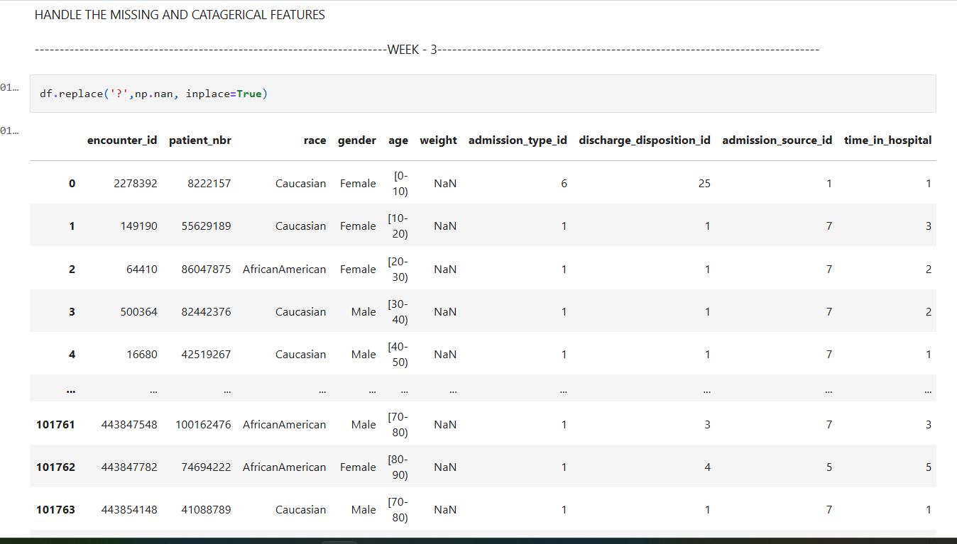

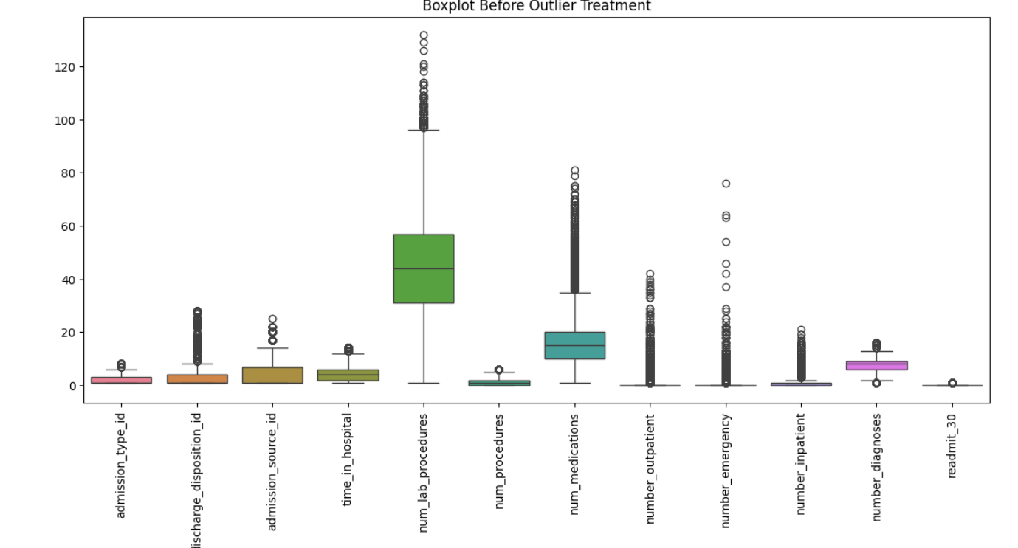

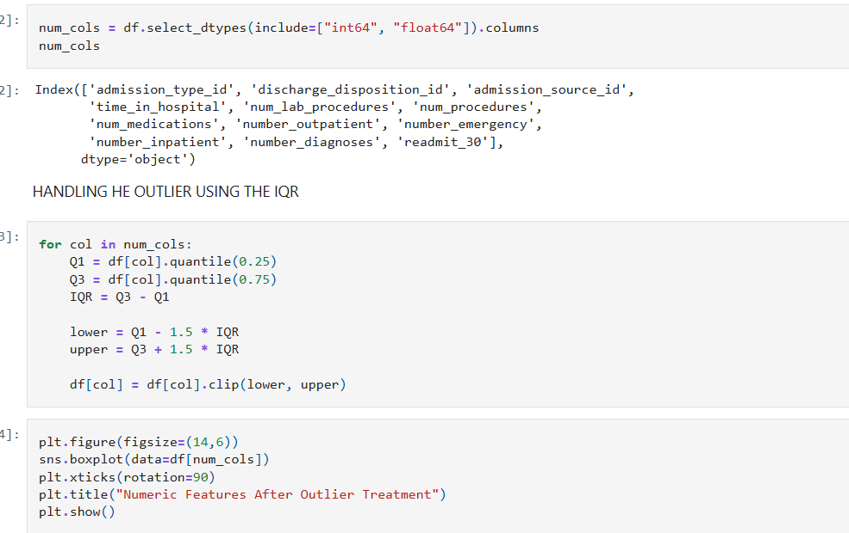
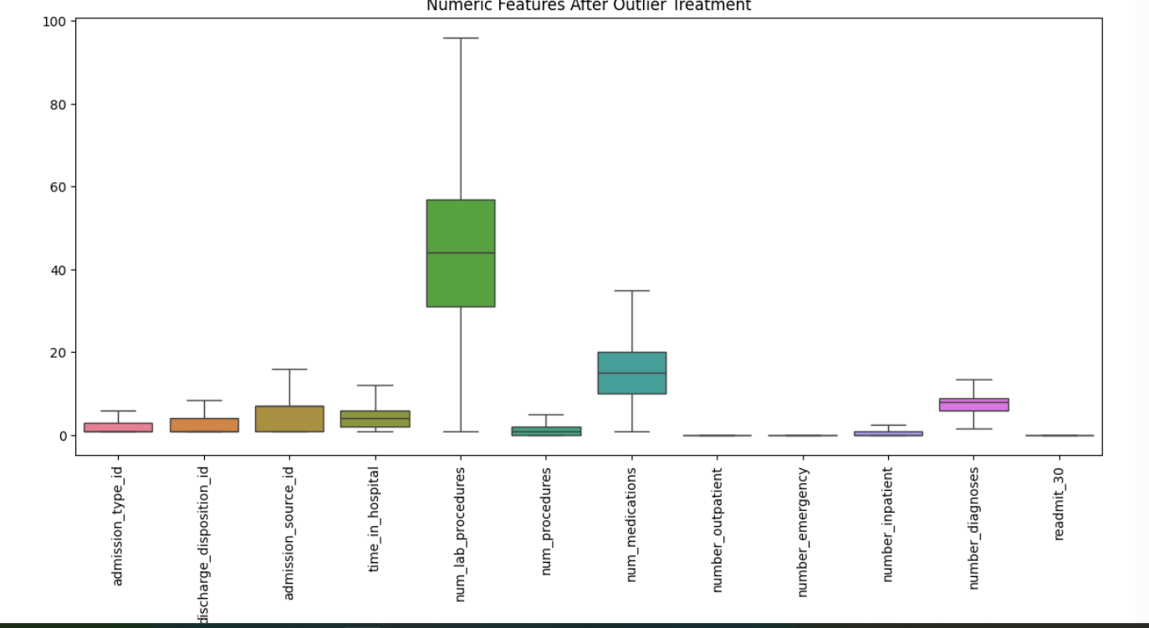

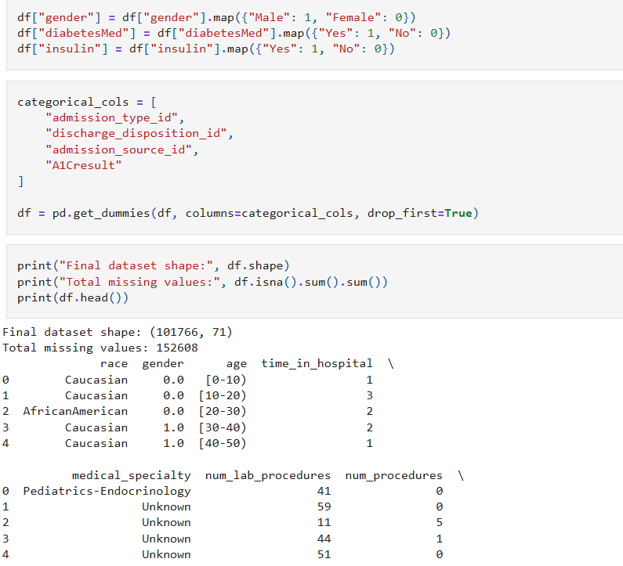
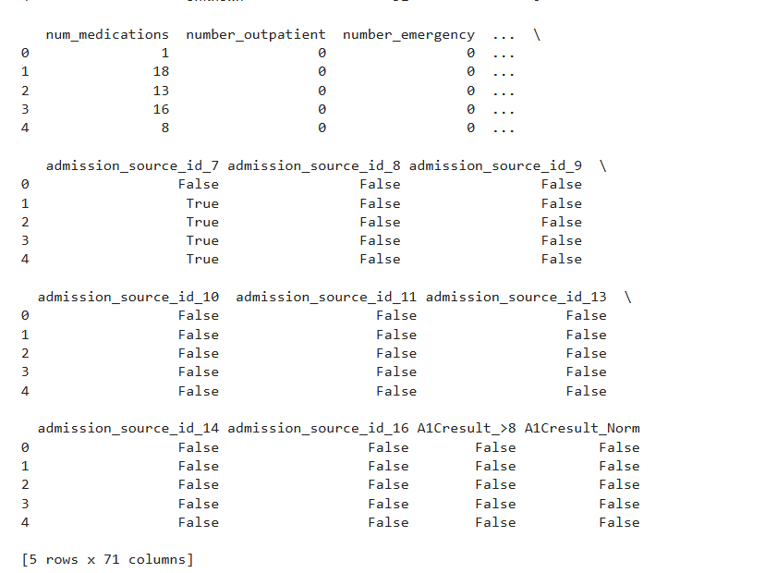
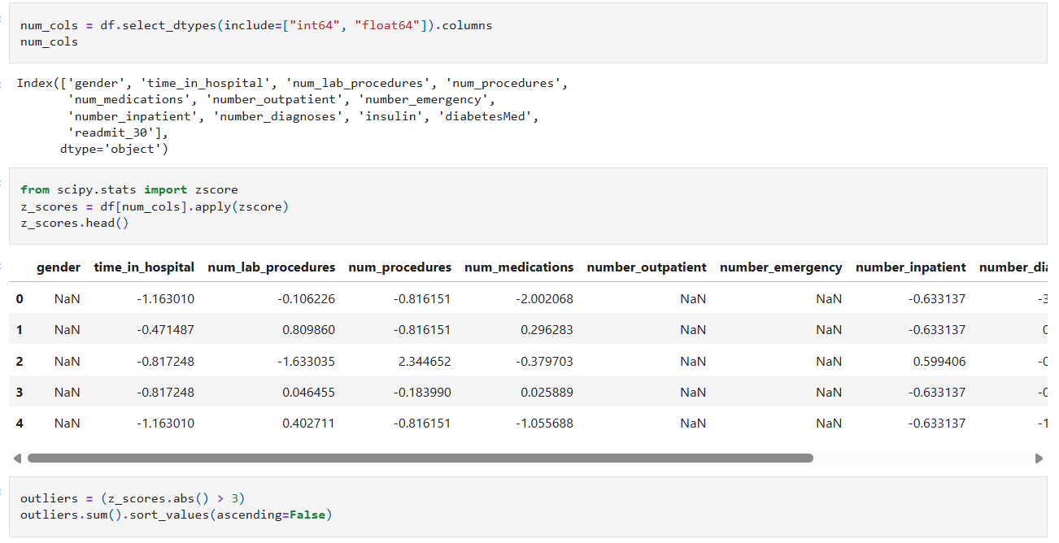
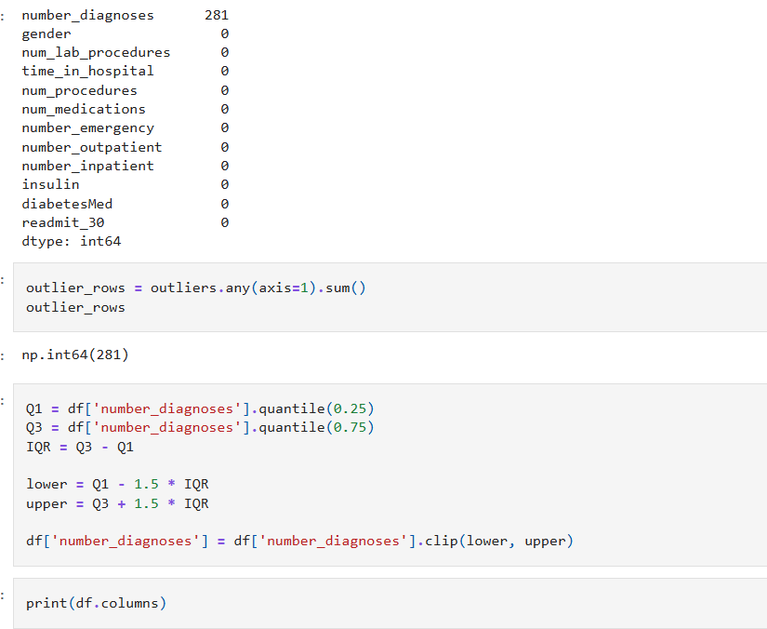

INTERPRETATION:
1. Before Outlier Treatment
The first boxplot shows the distribution of all numerical features before handling outliers.
Key observations:
- Significant outliers are present in many variables, especially:
  - num_lab_procedures → very high spread with extreme values above 120.
  - num_medications → several high outliers.
  - number_outpatient, number_emergency, number_inpatient → many scattered extreme points.
- Wide variation:
  - Features like num_lab_procedures and num_medications have large variability.
- Categorical encoded variables:
  - Features such as admission_type_id, discharge_disposition_id, and admission_source_id have smaller ranges but still contain some unusual values.

2. After Outlier Treatment
The second boxplot shows the numerical features after outlier handling (likely capping or removal).
Key observations:
- Extreme outliers have been reduced significantly:
Most variables now have fewer or no scattered points outside
whiskers.
- Better compactness:
The spread of features is more controlled.
- num_lab_procedures:
Still has a wide range, but extreme high values are reduced.
- num_medications:
Distribution is more balanced and less skewed.
- number_outpatient / emergency / inpatient:
Outliers have been controlled, improving consistency.

TEAM CONTRIBUTION:

TEAM MEMBER | CONTRIBUTION
GURUPRASAD N | Implemented missing value handling techniques, performed data imputation.
ANUSRI T | Generated visualizations and analyzed outliers using boxplots and completed the documentation work for Week-3.
SHALINI S | Reviewed the cleaned dataset and verified the preprocessing results after handling missing values and outliers.

WEEK 4:
EDA DEEP DIVE
OBJECTIVE:
To perform an in-depth Exploratory Data Analysis (EDA) by understanding and analyzing both univariate and bivariate data. The objective includes summarizing data characteristics, identifying patterns, trends, and outliers, and effectively visualizing distributions using appropriate graphical techniques to gain meaningful insights from the dataset.
UNIVARIATE ANALYSIS:
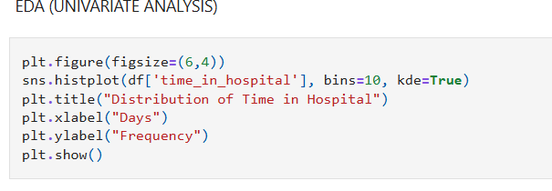
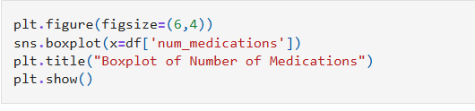
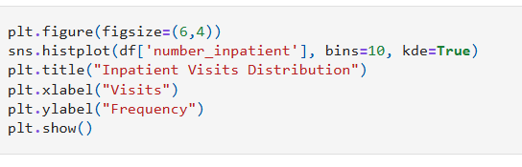
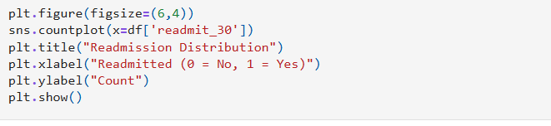
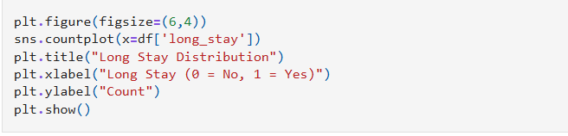
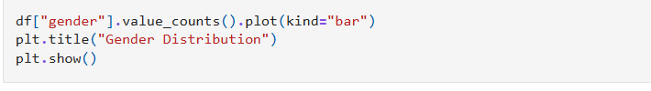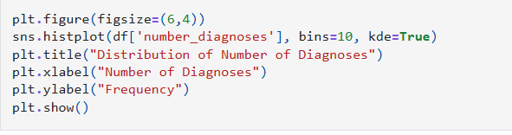
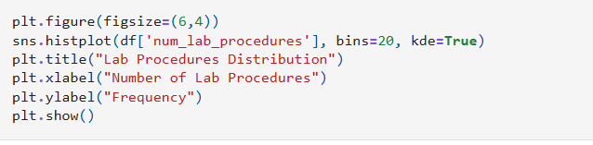
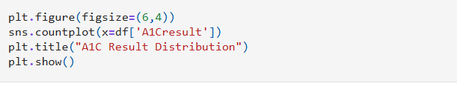

OUTPUT:
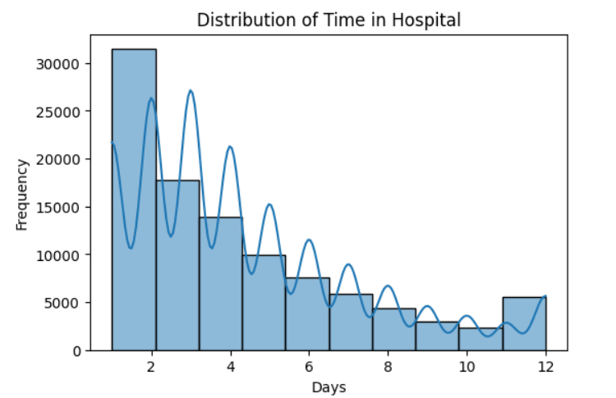
INTERPRETATION:
Most patients stay for a short duration, while only a few have longer hospital stays, indicating that long stays are less common.
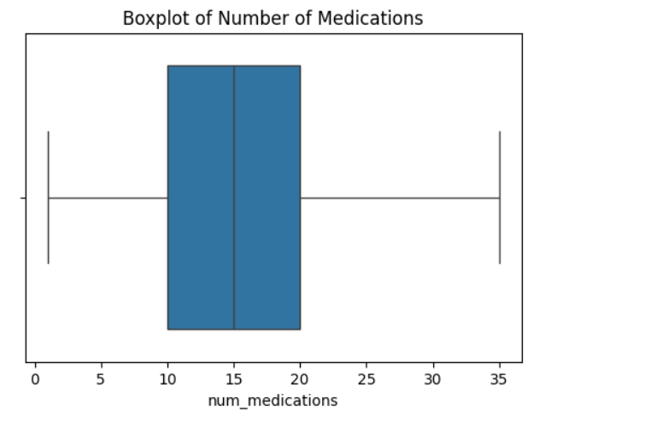
INTERPRETATION:
Some patients take significantly more medications than others, indicating possible severe medical conditions.
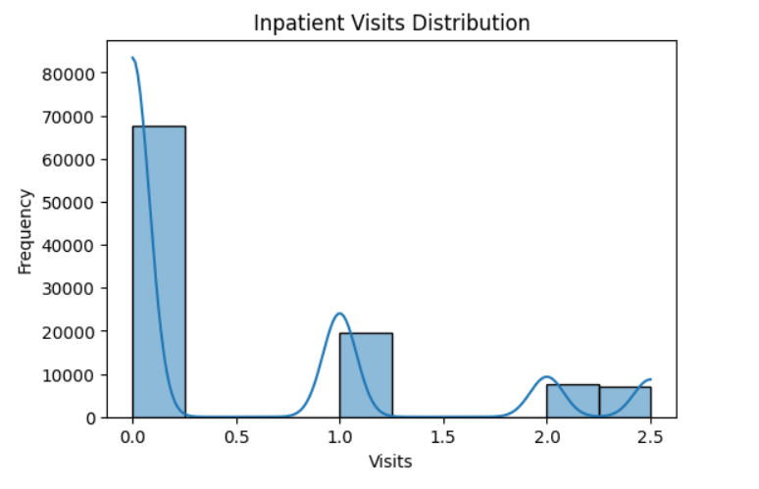
INTERPRETATION:
Most patients have fewer inpatient visits, while a small number of patients frequently visit the hospital.

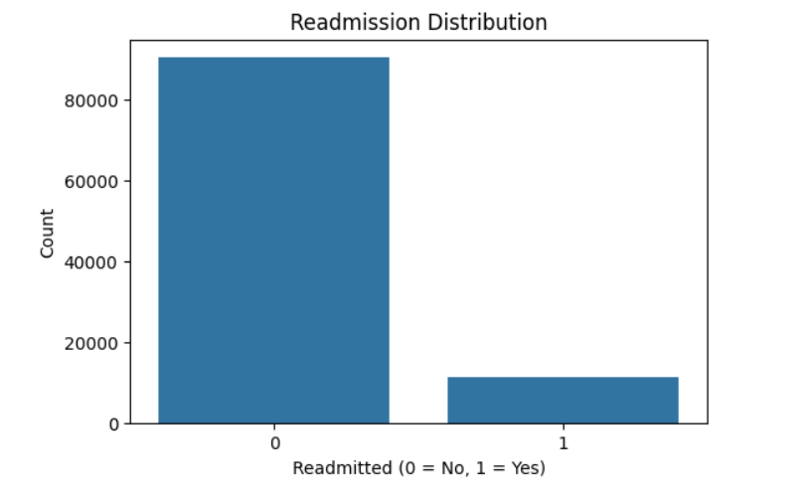
INTERPRETATION:
Majority of patients are not readmitted, indicating class imbalance in the dataset.
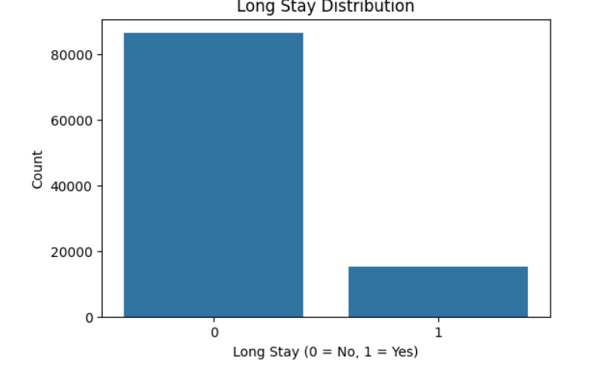

INTERPRETATION:
Most patients do not have long stays, but long-stay patients may represent more critical cases.
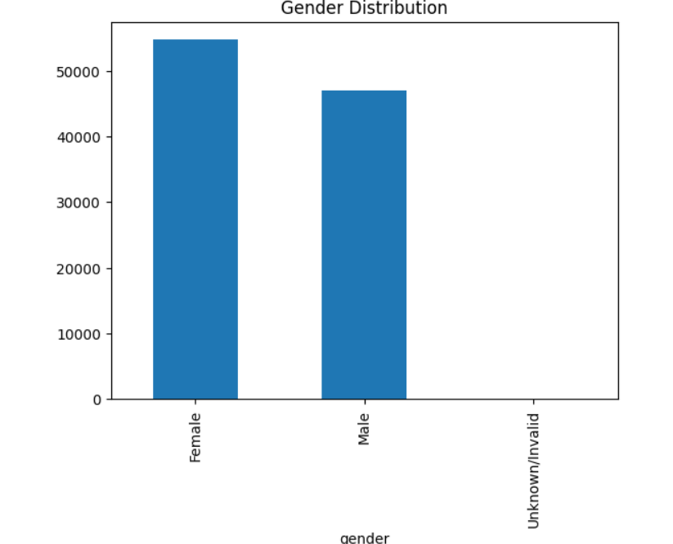
INTERPRETATION:
The graph shows the distribution of patients based on gender. It is observed that the number of female patients is slightly higher than male patients. The “Unknown/Invalid” category has very few entries, indicating minimal missing or incorrect gender data in the dataset.

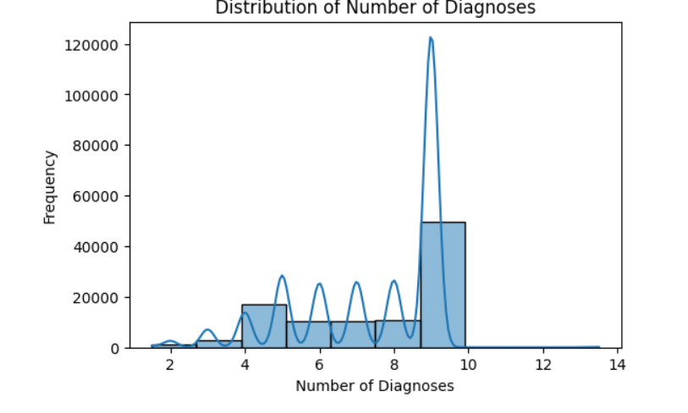
INTERPRETATION:
Most patients have a moderate number of diagnoses, while very high diagnosis counts are less frequent, indicating that severe multi-condition cases are limited.
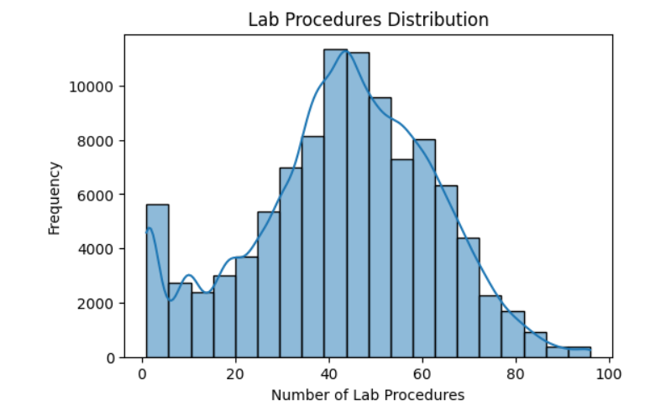
INTERPRETATION:
The number of lab procedures varies widely among patients, with most patients undergoing a moderate number of tests.
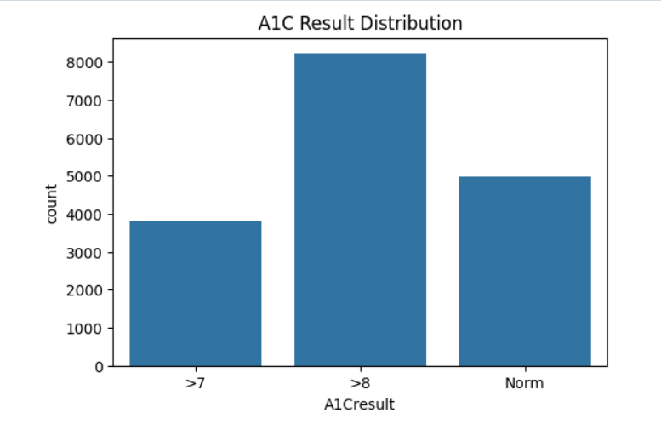

INTERPRETATION:
The distribution of A1C results shows that the majority of patients fall into category “3”, indicating that most patients do not have a recorded A1C result. Only a small number of patients fall into categories 0, 1, and 2, representing normal or abnormal glucose levels.

BIVARIATE ANALYSIS:
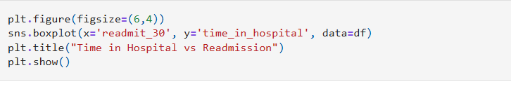
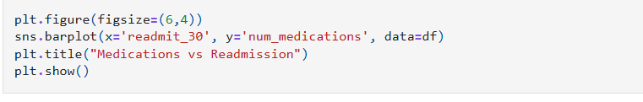
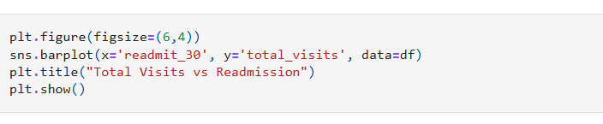
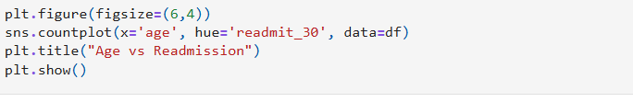
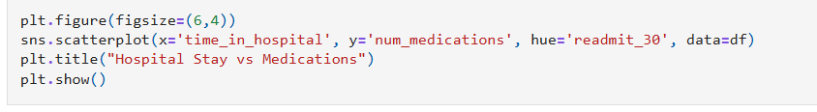
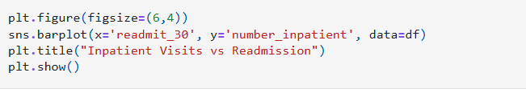
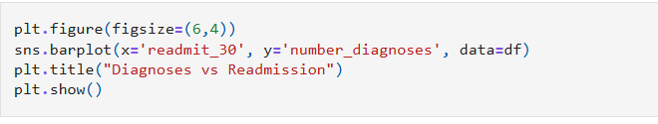

OUTPUT:
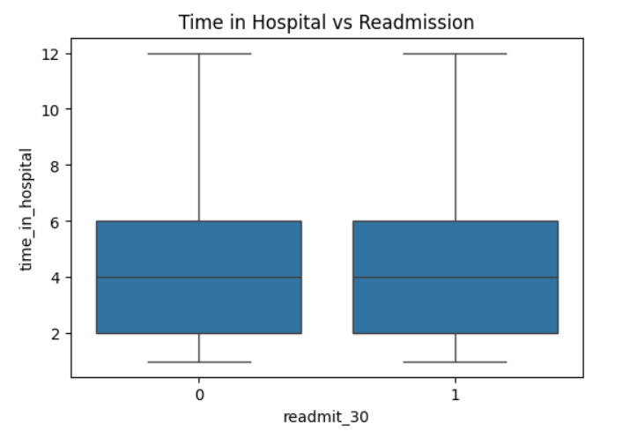
INTERPRETATION:
The boxplot shows that the distribution of hospital stay is very similar for both readmitted and non-readmitted patients. There is no significant difference in median or spread, indicating that hospital stay alone may not strongly influence readmission.
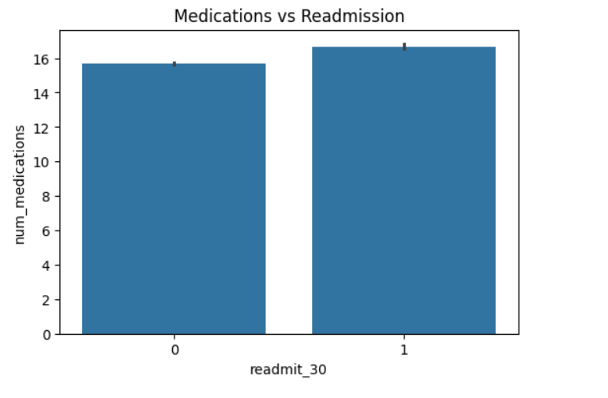
- The bar chart shows that patients who are readmitted have a slightly higher average number of medications compared to those who are not readmitted. This suggests that patients with more medications may have more complex health conditions, increasing the likelihood of readmission.
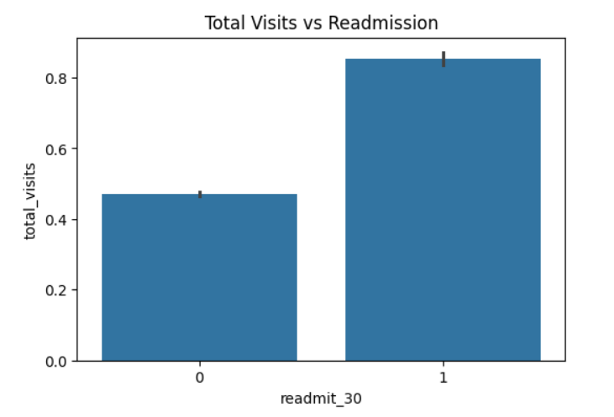
- The bar chart shows that patients who are readmitted have a significantly higher average number of total visits compared to those who are not readmitted. This indicates that frequent hospital visits are strongly associated with a higher likelihood of readmission.

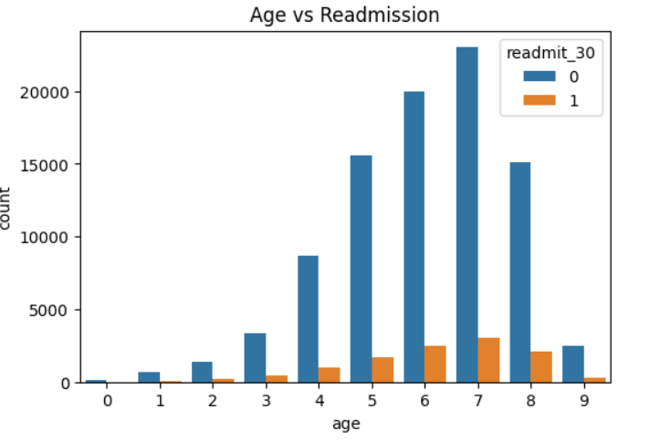
- The graph shows that the number of patients increases in higher age groups, and readmission cases are also more frequent in these groups. This indicates that older patients have a higher likelihood of readmission compared to younger patients.Age increases → patient count increases Readmission (orange bars) also increases with age

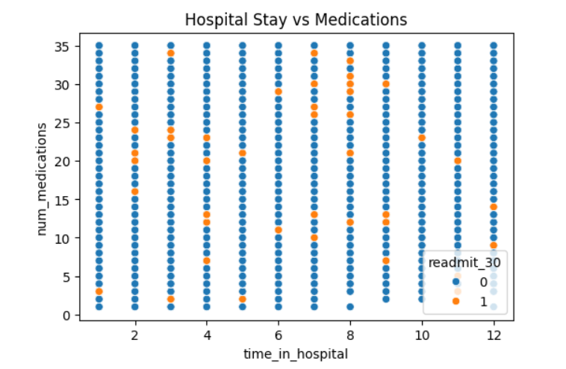
- The scatter plot shows the relationship between hospital stay duration and number of medications. The points are widely spread for all hospital stay values, so there is no strong visible trend between these two variables. Readmitted and non-readmitted patients overlap throughout the plot, indicating that these features alone do not clearly separate readmission cases.

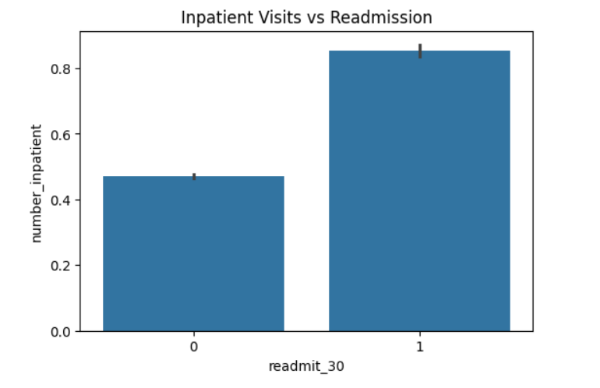
- The bar chart shows that patients who are readmitted have a higher average number of inpatient visits compared to those who are not readmitted. This indicates that frequent inpatient visits are associated with a higher likelihood of readmission.Readmit = 1 → ~0.85 (higher) Readmit = 0 → ~0.47 (lower)

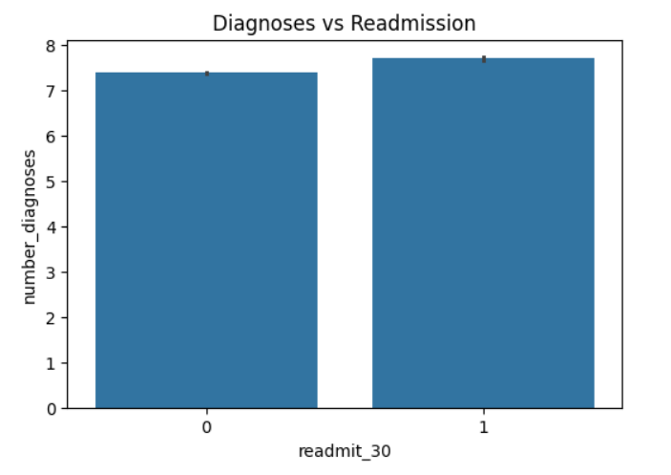
- The graph shows that the average number of diagnoses is slightly higher for readmitted patients compared to non-readmitted patients. However, the difference is very small, indicating that the number of diagnoses does not have a strong influence on readmission.Readmit = 1 → slightly higher (~7.7) Readmit = 0 → slightly lower (~7.4).

TEAM CONTRIBUTION:

TEAM MEMBER | CONTRIBUTION
GURUPRASAD N | Performed univariate analysis and created distribution plots, histograms, and boxplots to understand patterns.
ANUSRI T | Generated bivariate visualizations such as scatter plots and count plots, and analyzed the relationship between readmission and time.
SHALINI S | Reviewed all EDA results for accuracy and interpretation.

WEEK 6:
FEATURE ENGINEERING
OBJECTIVE:
To perform feature engineering by applying scaling techniques to numerical data, encoding categorical variables into suitable numerical formats in data distribution to improve data quality and enhance the performance of machine learning models.
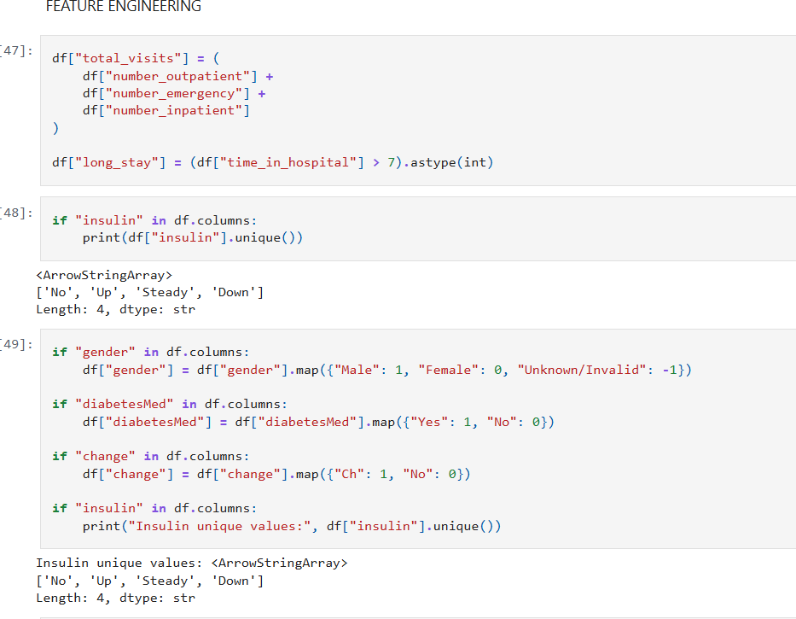

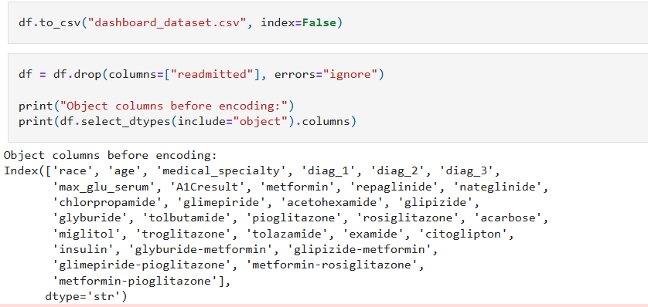
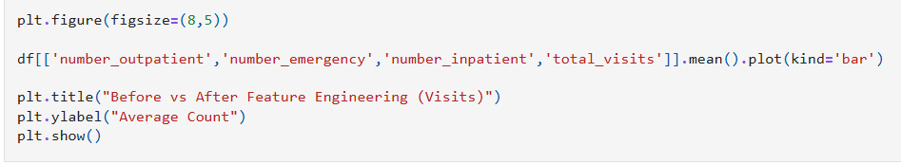
OUTPUT:
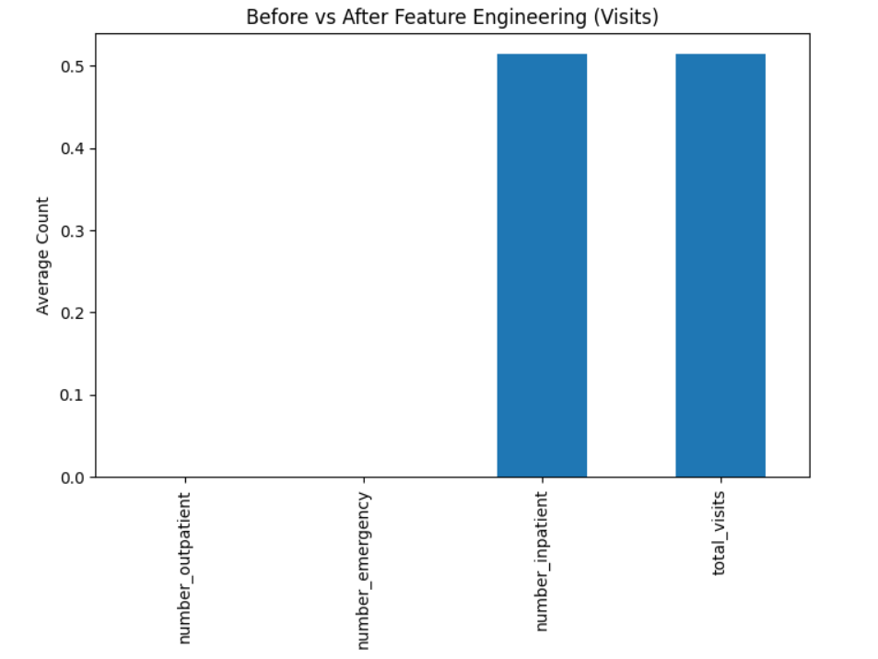

INTERPRETATION:
The graph compares the average values of original visit-related features with the engineered feature total_visits. It shows that outpatient and emergency visits have very low averages, while inpatient visits and total visits have higher values. This indicates that the engineered feature effectively combines visit information into a single meaningful variable.
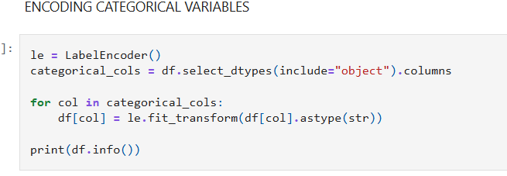
OUTPUT:
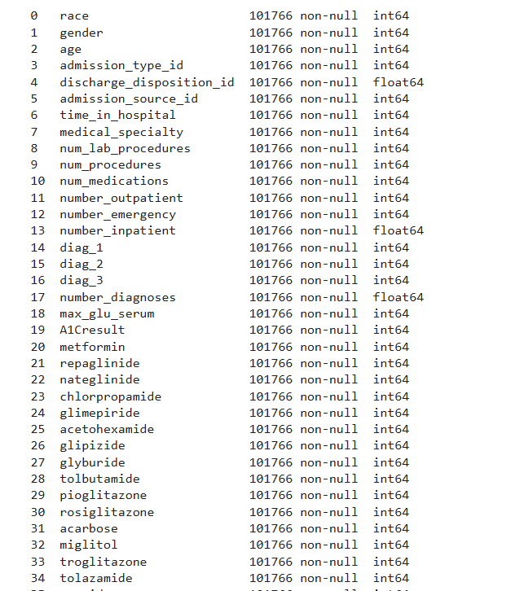
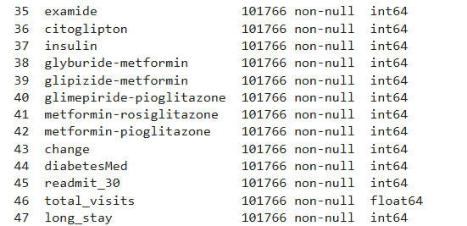
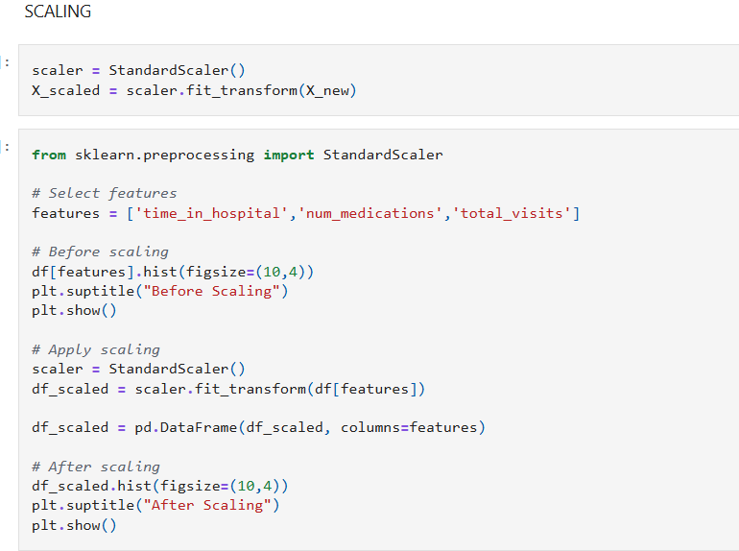
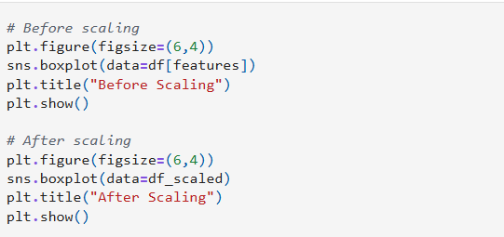
OUTPUT:
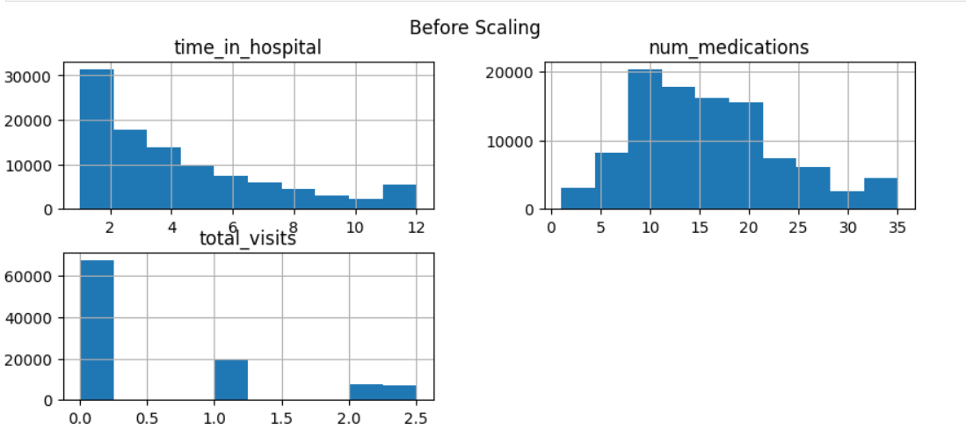
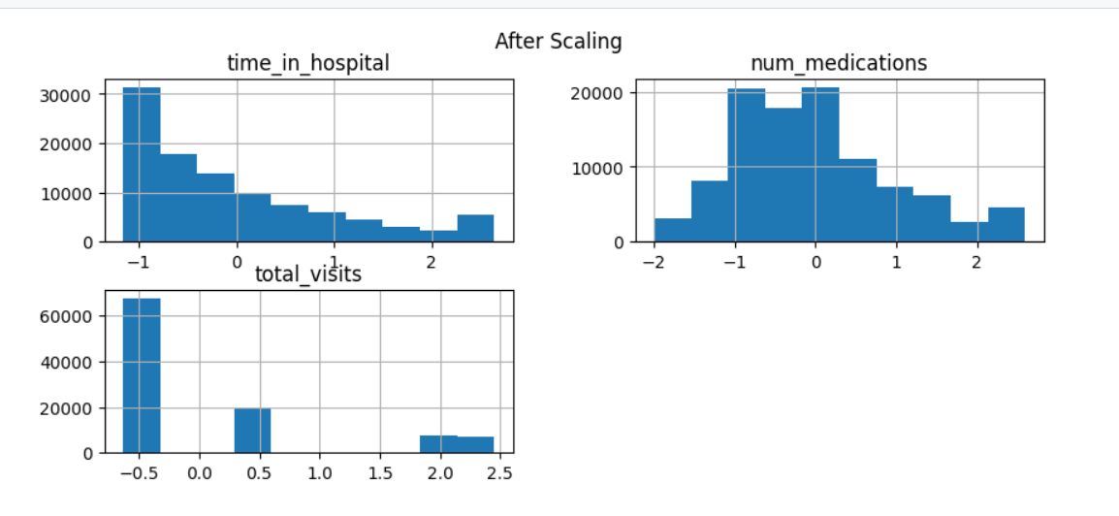
INTERPRETATION:
Before scaling, features have different ranges and distributions. After scaling, all features are standardized with mean around 0 and similar spread, improving model performance.
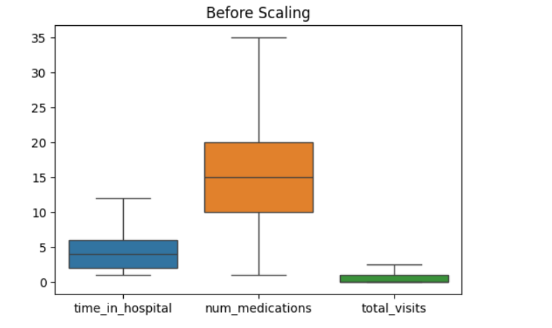
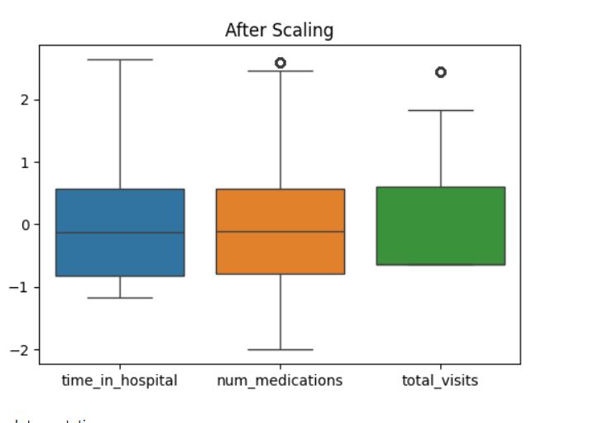
INTERPRETATION:
Before scaling, features have different ranges and spread. After scaling, all features are normalized to a similar scale, reducing the effect of outliers and improving comparability.
TEAM CONTRIBUTION:

TEAM MEMBER | CONTRIBUTION
GURUPRASAD N | Identified numerical features and applied scaling techniques.
ANUSRI T | Performed encoding of categorical variables and generated visualizations to analyze feature distributions after transformation.
SHALINI S | Verified the transformed dataset, reviewed feature engineering steps, and ensured the dataset was ready for machine learning models.

WEEK 7:
DIMENSIONALITY REDUCTION
OBJECTIVE:
To perform dimensionality reduction by applying feature selection techniques and Principal Component Analysis (PCA) in order to reduce the number of features, eliminate redundancy, and retain maximum variance in the dataset, thereby improving model efficiency and visualization of data patterns.
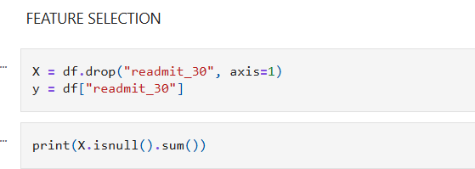
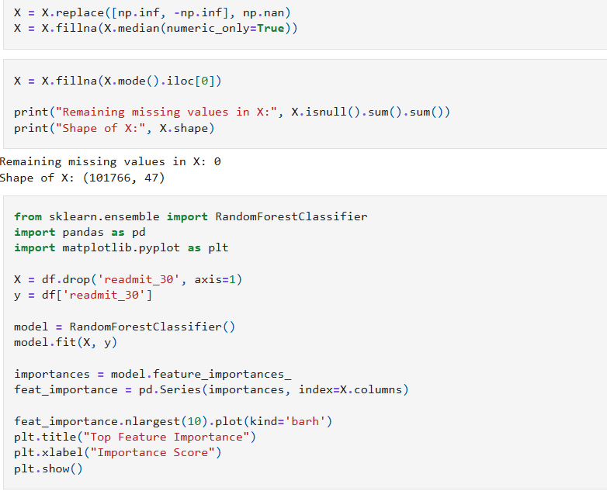
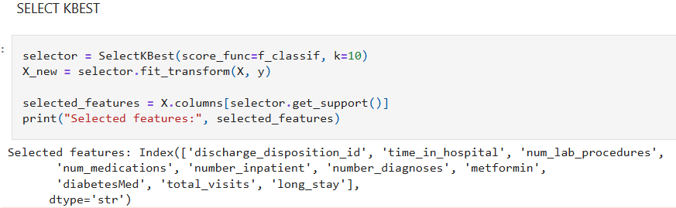
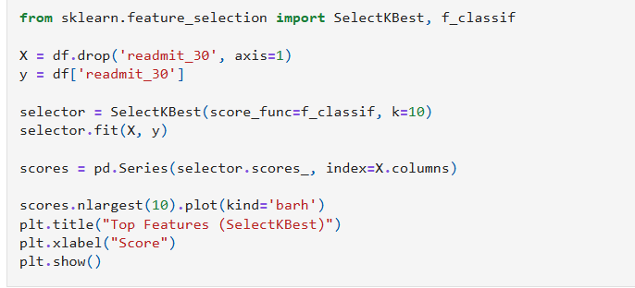
OUTPUT:
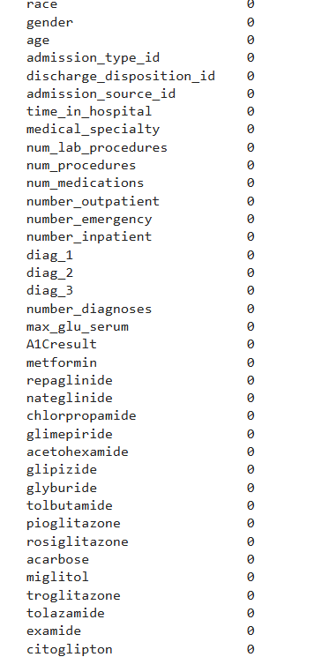
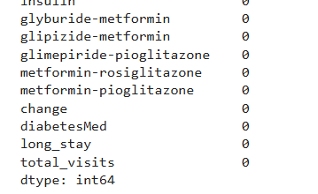
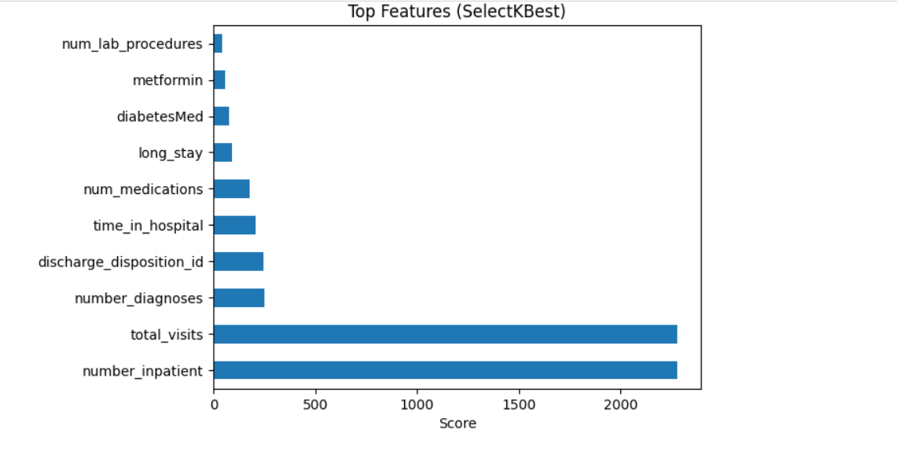
INTERPRETATION:
The SelectKBest graph shows the top features selected based on statistical tests. Features such as number of inpatient visits and total visits have the highest scores, indicating a strong relationship with readmission. Other features like number of diagnoses, discharge disposition, and time in hospital have moderate importance, while remaining features have lower influence.

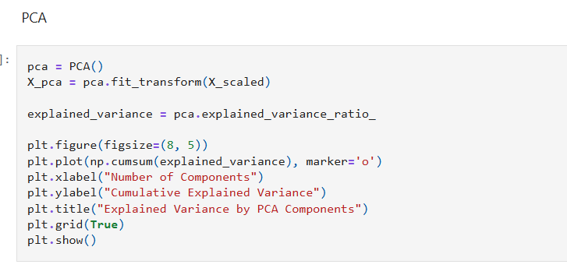
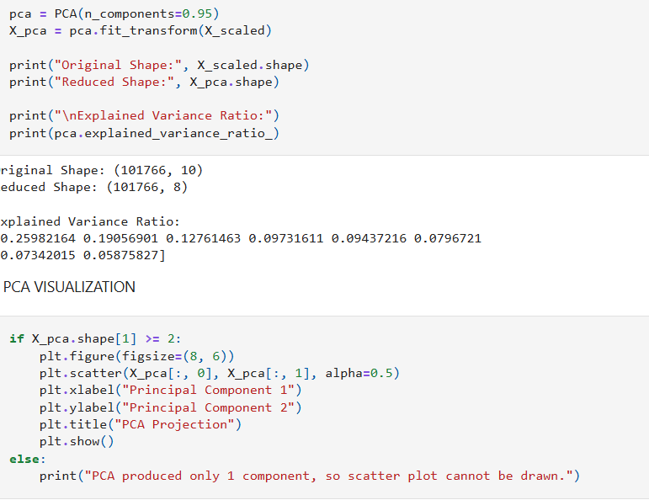

OUTPUT:
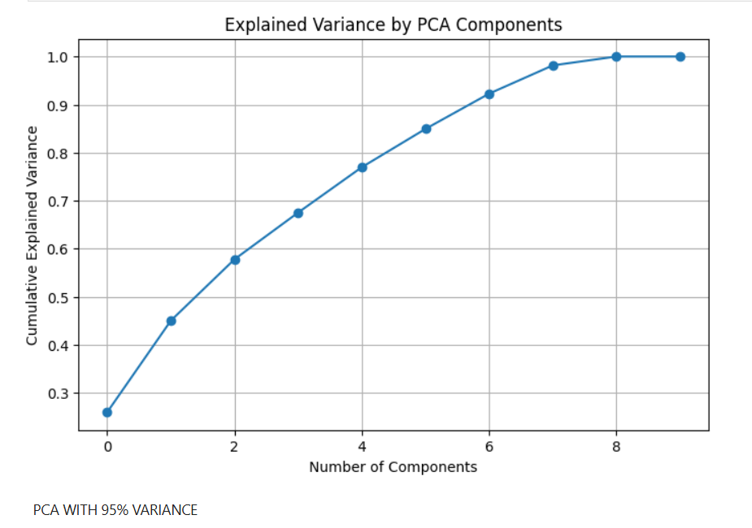
INTERPRETATION:
- As the number of principal components increases, the cumulative explained variance also increases.
- Around 6–7 components, the variance reaches ~95%, meaning most of the information in the data is captured.
- After this point, adding more components gives very little improvement → this is the optimal number of components.
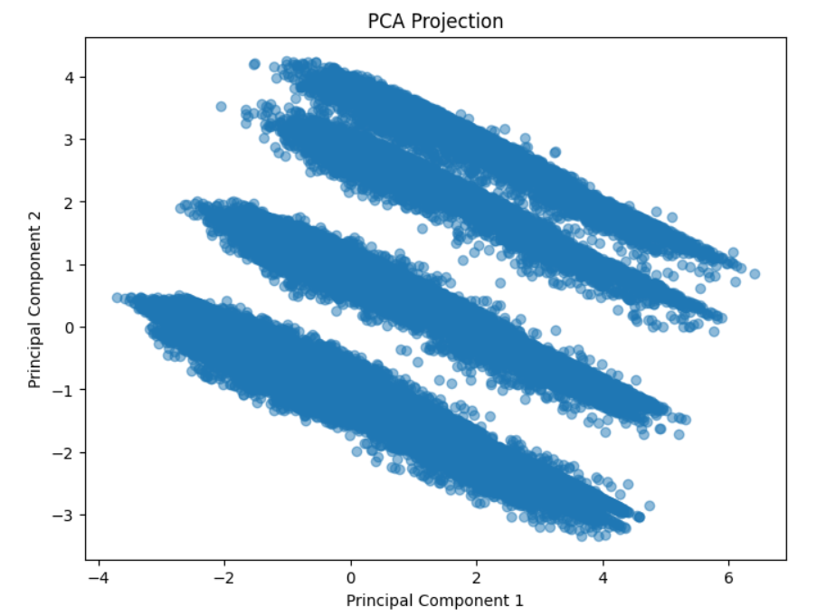
INTERPRETATION:
- Data is projected onto the first two principal components (PC1 and PC2).
- The points form clear linear clusters/strips, showing strong patterns in the data.
- This indicates that Principal Component Analysis successfully reduced dimensions while preserving structure.
- The separation suggests that the data may have underlying groups or correlations.

TEAM CONTRIBUTION:
TEAM MEMBER | CONTRIBUTION
GURUPRASAD N | Performed feature selection by identifying important features and removing irrelevant or redundant variables.
ANUSRI T | Implemented PCA and generated visualizations to analyze variance and reduced feature space.
SHALINI S | Analyzed explained variance ratio and determined the optimal number of principal components.

OBJECTIVE:
To develop the ability to design and build an interactive data dashboard using tools like Streamlit or Plotly, and to present data as a clear, cohesive story.
This includes:
Transforming raw data insights into a structured narrative
Integrating multiple visualizations into a single, unified dashboard

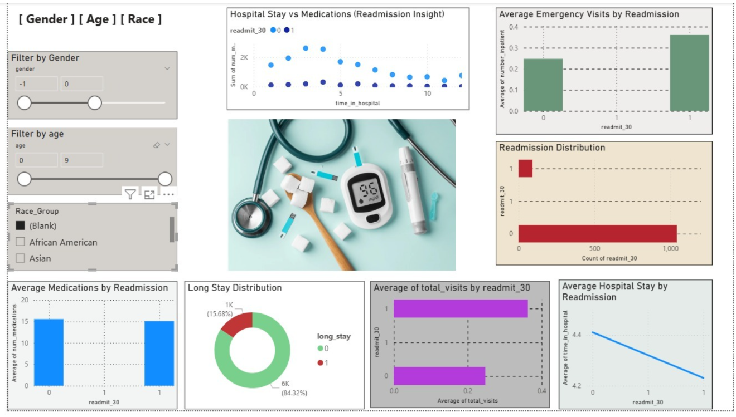

Types of Visualizations Used
A variety of visualizations were used to analyze and present the data effectively:
- Bar Charts:
Used to compare readmission status with features like emergency visits, medications, and total visits.
- Line Chart:
Used to show trends such as average hospital stay across readmission categories.
- Scatter Plot:
Displays the relationship between time in hospital and number of medications, highlighting readmission patterns.
- Donut Chart (Pie Chart):
Represents the distribution of long-stay vs short-stay patients.

Dashboard Explanation

Used for comparing average values like total visits across readmission groups. The dashboard provides an interactive overview of diabetic patient readmission patterns using filters for gender, age, and race. It highlights that patients with longer hospital stays, higher medication counts, and more emergency or total visits are more likely to be readmitted. The visualizations also show that while most patients are not readmitted, a notable portion remains at risk. Overall, the dashboard combines multiple insights in a clear and user-friendly way, helping to identify high-risk patients and support better healthcare decisions.

TEAM CONTRIBUTION:
TEAM MEMBER | CONTRIBUTION
GURUPRASAD N | Visualization Design,  Created charts using Plotly  Designed bar plots and scatter plots
ANUSRI T | Applied Principal Component Analysis,  Integrated data using Streamlit, Improved visual clarity and labelling.
SHALINI S | Dashboard Integration & Storytelling  Combined all visuals into one dashboard

